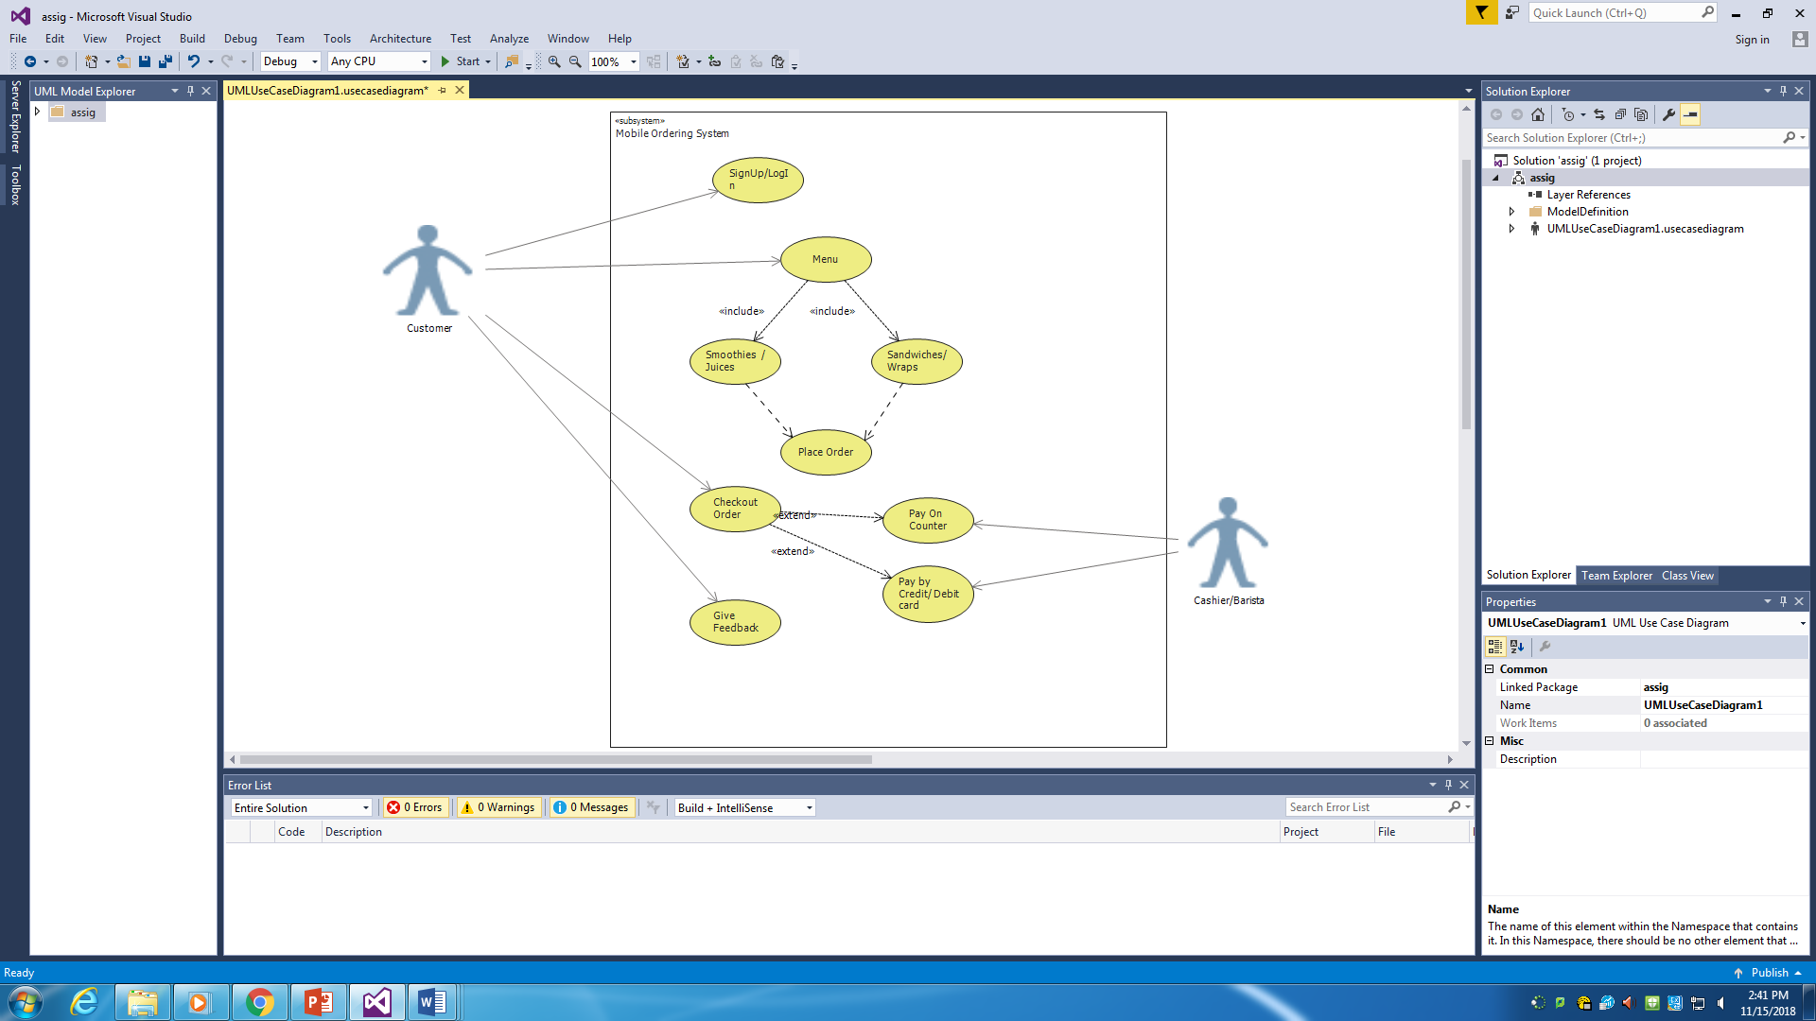**Description of the Use Case Diagram:**

Mobile Ordering System:

Primary Actor: Customer and Cashier/Barista.

Level: 1- Sea

Stakeholder: Customer.

Precondition: Customer visiting the Jugo Juice mobile application.

Minimal Guarantee: Rollback of any uncompleted transaction.

Success Guarantee: Drinks and Foods will be prepared in a given time.

Trigger: Customer access to application.

Main Success Scenario:

1. First, customers asked for Signup or Login.
2. Customers will open the menu in which they will select smoothies/juices or food.
3. In the third option, customers will have asked for placing the order and checked out it.
4. And then, the customers have to pay the bill on counter or by credit and debit card / (online banking).
5. In the last, they have to give the feedback for their order and service.

Extensions:

1. Customer gets error to login or signup, our team will be there to solve the problem.
2. If customer wants to cancel the paid order, they will get the full amount of money back.
3. If the customers need any information about our drinks, foods, or any other services, they can contact the jugo juice helpline contact or submit their questions with there email. Our team will love to tell them about our drinks and food